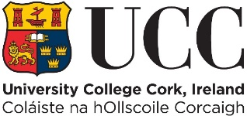

**Cover Sheet for On-Line Examinations**

**Summer 2020**

**Student Number:** 118364841

**Module Code: CS2514**

**Programme and Year of study:** Data Science and Analytics II

(e.g., Arts III, Food Science II)

**Date and Time of Examination** 24/04/2020 09:00

**Place X in box if registered with DSS:**

**Place X in box if availing of a spelling and grammar waiver**

(for marking guidelines, see <https://www.ucc.ie/en/dss/publications/>)

**ALL ANSWERS SUBMITTED WILL BE CHECKED BY TURNITIN**

**Student Declaration**

This is to certify that the work I am submitting is my own and has been done by me solely and not in consultation with anyone else. Neither I nor anyone else have submitted this work for assessment, either at University College Cork or elsewhere. I have read and understood the regulations of University College Cork concerning plagiarism. Where breaches of the declaration are detected, these will be reviewed under UCC student conduct and plagiarism policies. Any breach of the examination rules is a serious issue and can incur penalties.